**St Tammany Parish Sheriff’s Office**

**Crime Laboratory**

LSG.2017

**Laboratory Services**

**Guide to Collection, Submission, and Analysis**

**Effective**

**1/15/2017**

Contents

1.0 Preface 3

2.0 Introduction 3

3.0 Contact Information 3

4.0 Hours of Operation 3

5.0 Services Provided 3

6.0 Coverage Area 4

7.0 General Safety Information 4

8.0 General Case and Evidence Acceptance Policies 4

9.0 Packaging 5

10.0 Sealing 6

11.0 Labeling 7

12.0 Request for Laboratory Services, Inspection Services or Information 7

I. Requests for Laboratory Services 7

II. Requests for Crime Scene Investigation 8

III. Requests for Information 8

13.0 Discipline Specific Information 8

I. Controlled Substances Analysis 8

II. Trace 10

Primer GSR Analysis 10

III. Firearms and Tool marks 12

IV. Latent Prints 14

V. Digital Forensics 16

VII. Crime Scene 17

**Version History** 18

# Preface

The purpose of this document is to offer general guidance to law enforcement agencies on the analysis performed by the St. Tammany Parish Sheriff’s Office Crime Lab and how to effectively submit evidence to STPSO Crime Lab. Proper evidence handling is necessary to ensure the preservation of the evidence, the integrity of analytical results, and the admissibility of the evidence in a court of law.

# Introduction

The STPSO Crime Lab provides quality forensic science testing, written reports of results, and subsequent expert testimony on matters relative to criminal statutes.

# Contact Information

|  |  |  |
| --- | --- | --- |
| Address |  | Contact Information |
| 300 Brownswitch Road |  | P.O. Box 1229 |
| Building 2 |  | Slidell, LA 70459 |
| Slidell, LA 70458 |  | Phone: (985) 276-1200 |
|  |  | Fax: (985) 276-1233 |
| **Website:**  <https://www.stpso.com/divisions/professional-standards/crime-lab/> | | |
| **Email:** [**crimelab@stpso.com**](mailto:crimelab@stpso.com) | | |

# Hours of Operation

|  |  |  |  |
| --- | --- | --- | --- |
| **Activity** | **Days** | **Morning Hours** | **Afternoon Hours** |
| Fingerprinting (fee for service) | T/TH | 8:00AM-11:00AM | 1:00PM – 4:00PM |
| Evidence Intake (by appointment) | M/W/F | 8:30AM-11:00AM | 1:00PM – 4:00PM |

# Services Provided

The STPSO Crime Lab provides forensic testing in the disciplines of controlled substances; trace evidence: gunshot residue; digital forensics (computers, cellphones, etc.), latent prints; and crime scene.

Cases are traditionally worked in order based on the date of receipt by the lab.

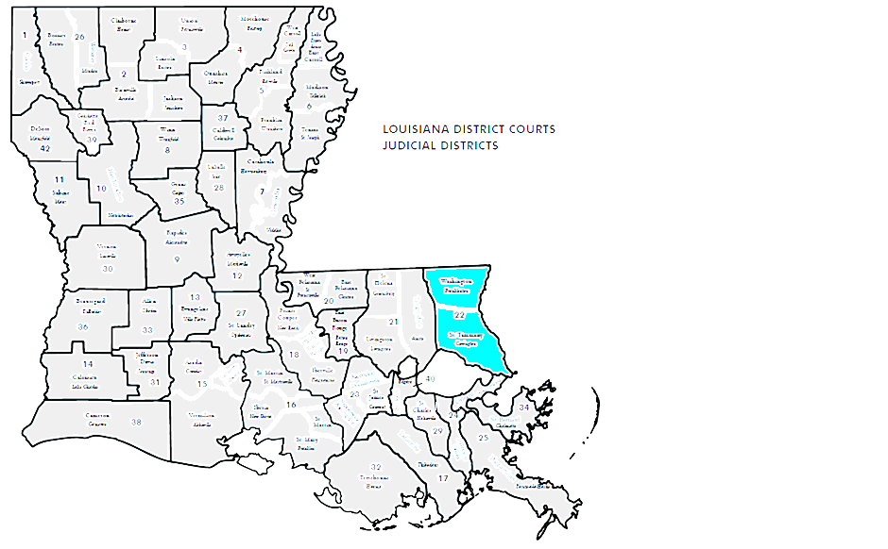Customers may request that a case receive **“Rush”** status. The request must be in writing and contain minimally: case number, reason for request, and preferred date of receipt.

# Coverage Area

The STPSO Crime Lab routinely provides services to the Louisiana 22nd Judicial District which includes St. Tammany and Washington Parishes. Other agencies may request services from the STPSO Crime Lab; however, service provision is at the discretion of the STPSO Crime Lab.

# General Safety Information

Figure : 22nd Judicial District

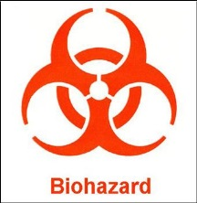Physical evidence being submitted for forensic testing can pose significant safety hazards. It may not always be possible to determine if evidence poses a biological or chemical hazard, so it is imperative to follow universal safety precautions when handling all evidence. According to the concept of Universal Safety Precautions, all human blood and certain body fluids are treated as if known to be infectious for human immunodeficiency virus (HIV), hepatitis B virus (HBV), and other blood borne pathogens. All body fluids should be handled with caution.

**Evidence that is a potential biohazard should be plainly marked with biohazard stickers**.

**Suspected hazardous chemicals and sharps must also be plainly marked.**

# General Case and Evidence Acceptance Policies

The STPSO Crime Lab will receive and examine evidence submitted by the criminal justice community investigating a potential criminal action.

The following types of cases and/or evidence not generally accepted:

* Evidence from private individuals or businesses.
* Non-criminal, not capable of being charged criminally, or not probative in a cause of death determination.
* Requests which limit the scope of the agency’s investigation.
* “Compromised” or affected evidence that renders scientific examinations invalid.
* Previously examined evidence. The Crime Lab Director or designee may allow exceptions to this policy on a case-by- case basis.

# Packaging

Proper packaging, identification, and sealing of evidence is imperative to its preservation and integrity. Keep in mind to **change gloves between handling different items of evidence**.

Evidence should be packaged:

* In the manner in which it was found. Items found in contact with each other, should be packaged together.
* 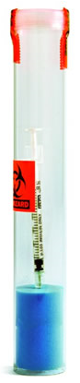Items collected from different locations should be packaged separately so that cross contamination cannot occur. If the potential for cross contamination does not exist, like items may be packaged together (e.g. inked elimination prints, latent print lifts from a specific collection area).
* And submitted dry (e.g. bloody clothing, plant material).
* To avoid breakage and/or leakage.
* To keep items for separate defendants separate.
* To protect employees from injury from biological, chemical, or sharps hazards.

**Sharps (syringes, knives, etc) must be packaged in sharps containers**. These containers can only be placed within clear plastic evidence bags to ensure the sharps container is visible to evidence intake personnel.

**All bags or envelopes used for evidence submissions should be no smaller than 4” x 6” to allow lab personnel room to properly label, open and reseal the evidence submission**.

Appropriate packaging includes but is not limited to: paper bags or envelopes, sturdy cardboard boxes, plastic bags, metal cans, sharps containers, and plastic jars.

Paper is suitable for most items because it is a porous material which allows residual moisture to escape

Plastic bags are preferred for drug evidence; they are **NOT suitable for live plants**

Cardboard (not coated in wax) is porous and also allows residual moisture to escape.



 

For more section specific packaging details, consult the appropriate section within this manual or contact Crime Lab personnel.

Evidence that is not properly packaged cannot be accepted by the Crime Lab for examination.

Items requiring collection of latent prints and/or contact DNA should be **clearly marked “Prints” or “DNA” on the outer most packaging** (not the packaging that will be processed for prints or DNA) to ensure it is routed correctly.

# Sealing

Evidence is properly sealed when its packaging is secured to prevent loss, cross-contamination, and/or unauthorized access to the contents. Openings should be covered with tamper indicating tape or should be in packaging with tamper proof seals. Factory sealed closures do not need to be covered with evidence tape. A proper seal should be initialed in permanent ink by the sealer.

**STPSO**

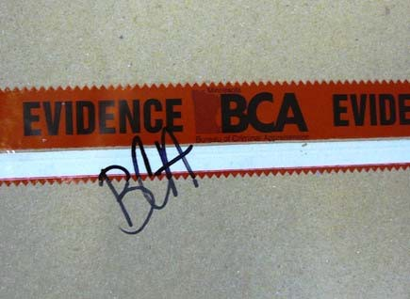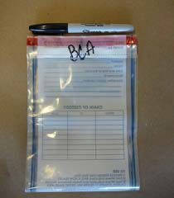

Oversized items or evidence that do not fit in traditional packaging (e.g. doors bearing tool marks, furniture, etc.) need to have the area of interest covered to protect from loss or alteration.

Evidence that is not properly sealed cannot be accepted by the Crime Lab for examination.

* Boxes: A box container seal includes the long seam at both the top and bottom of the box.
* Paper sacks, bags: Sealed by folding down the flap of the sack across the top and placing a continuous piece of tamper indicating tape, across the fold.
* Envelopes: The top (unsealed) flap of the envelope should be sealed along or across the seam using tamper indicating tape.
* Plastic bags including heat seals: Opening(s) are sealed with tamper indicating tape .
* Cans/bottles/ jars: tape must extend across the container/lid junction in at least one area.
* Box Kits: Boxed sexual assault kits, GSR kits, and other purchased kits are acceptable with the seal provided by the kit manufacturer.
* Bulky Evidence: isolate and protect the area of interest, mark and initial covering.

# C:\Users\jlclements20\Desktop\Evidence Label Image.jpgLabeling

Evidence/Property Label

Each exhibit should be labeled on the exterior of the packaging with a “label” or permanent ink, minimally, with:

* Agency Case Number
* Signal
* Exhibit Number
* Date/Time of Collection
* Collection Agent
* Exhibit Description
* Suspect, if known
* Victim, if known
* Location of collection

# Request for Laboratory Services, Inspection Services or Information

## Requests for Laboratory Services

When submitting new or additional evidence, a Request for Service is required for all non-routine analysis. Issuance of a lab number to a non-routine request for service constitutes an acceptance of the contract between the submitting agent and the lab.



***STPSO requests*** - Requests for service are typically initiated through the evidence/property label seen above. Routine activities that do not require a lab request for services are primer GSR analysis and test fires where there is no exchange of custody.

***Non-STPSO requests*** - Requests for services are typically initiated through the Request for Services form. Evidence that will be routed to different departments must be submitted on separate forms; this doesn’t apply to one piece of evidence requiring multiple services (i.e. narcotics also requiring fingerprint processing). Routine activities that do not require a lab request for services are: test fires where there is no exchange of custody

The following disciplines have supplemental forms that should be included with evidence submitted for analysis.

*Trace Evidence Analysis – GSR Kits should contain a case information sheet.*

*Digital Forensics – Additional forms are required to fulfill a request for service. Please contact the Digital Forensics division for instructions.*

*Form DF1 Computers*

*Form DF2 Cell Phones*

*Form DF3 Cell Phones Additional Exhibits*

*Form DF4 Computers Additional Exhibits*

If you have any questions on what case information needs to be supplied, contact the Crime Lab and our personnel will assist you.

## Requests for Crime Scene Investigation

***STPSO requests*** - Requests for service are initiated through the CAD system and are maintained under STPSO agency case numbers

***Non-STPSO requests*** - Requests for service must be approved by the lab director or designee, at a minimum. All agencies requesting assistance agree to the transferal of the scene to STPSO personnel to be worked according to STPSO policies and procedures. Issuance of an STPSO agency case number constitutes an acceptance of the contract between the requesting agency and the STPSO Crime Lab.

## Requests for Information

All requests for information are initiated by completing a Request for Information form. These requests include copies of scene sketch, mug shot, 10 print, rap sheets, line ups, reports, scene photos, and case rush requests.



Failure to properly complete the Request for Information form may delay or negate the request.

# Discipline Specific Information

## Controlled Substances Analysis

#### Overview of Services

* Analyzes and identifies suspected controlled substances, clandestinely manufactured products, pharmaceutical products, and psychoactive plant material.
* Concentration or purity analyses are not performed by this lab.
* The Crime Lab does not generally identify isomers.
* Certain cases may require additional analysis due to federal regulations. Ex. Salt form determination of cocaine is only required for cases that will be federally prosecuted.
* Do not submit field test kits; empty plastic bags, bottles, and containers; currency.

Identifications are typically made utilizing color tests, crystal tests, microscopy, gas chromatography/ mass spectrometry (GC/MS) and/or Fourier Transform Infrared Spectroscopy (FTIR) instrumentation. Instruments and tests utilized will be stated in the results section of the report.

#### Case and Evidence Acceptance

Analysis of the following items is not guaranteed in all cases and may require the approval of Crime Laboratory Management.

* Syringes
* Drug paraphernalia,
* Residue or trace amounts (trace amounts are defined as residue that may or may not be visible and do not have a weight over 0.01 grams).
* Plant seeds

Items that are degraded due to mold pose a safety hazard to analysts. These items will be evaluated for analysis suitability on a case by case basis.

#### Collection and Packaging

Drug evidence seized from different individuals should be submitted in separate packaging with the owner clearly identified.

Dry controlled substance evidence should be packaged in clear, plastic bags

Live plants or wet items should be packaged, in paper.

Mushrooms should be submitted to the lab for analysis within 24 hours or stored in a dry environment not exceeding temperatures of 80 degrees Celsius.. Mushroom spores should not be submitted.

LSD is light and heat sensistive. Suspected LSD should be delivered to the lab or kept in a cool dark place.

Evidence that pose a danger to analyst safety, like syringes, should be packaged in clear, plastic “sharps” containers, any additional packaging should be plastic to ensure the sharps container is visible.

Biohazards should be labeled appropriately (body cavity samples, syringe contents).

Clan labs should only be dismantled by trained hazardous material personnel.

#### Results

The names of all substances that meet the requirements for identification are listed on the report.

The Crime Lab does not report scheduling information.

The Crime Lab does not generally identify isomers. Isomers are molecules with the same chemical makeup but different spacial arrangements. Substances commonly seen in this section with isomers include but are not limited to: amphetamines, ephedrine, methorphan, synthetic cannabinoids, and substituted cathinones (bath salts). If applicable, the Crime Lab will report “Isomeric form not determined” for any substance in which the isomeric form was not identified through the course of routine analysis.

## Trace

This section focuses on analysis of evidence that is small and not immediately observable to the investigator. The goal of analysis is identification of the material through instrumental analysis or through comparison of an unknown sample to a known suspected source. This section currently analyzes primer gunshot residue.

Instruments that may be utilized in these examinations include the Scanning Electron Microscope (SEM) and Energy Dispersive Spectrometer (EDS). Instruments utilized will be stated in the results section of the report.

### **Primer GSR Analysis**

#### Overview of Services

* Examine the morphology and elemental composition of microscopic particles to determine if they may have originated from primer gunshot residue
* GSR analysis cannot be used for distance determination, determination of firing angles, or association with a particular firearm or ammunition.

Gunshot residue (GSR), also known as primer residue, refers to the microscopic particles of metal and metal compounds that are emitted by a firearm at the time it is discharged. These particles may be deposited on a shooter’s hands or nearby surface depending on the type, caliber, condition of the weapon used, and the environmental conditions at the time of the use.

Particles characteristic of primer gunshot residue typically contain all three of the elements lead, barium, and antimony. However, not all types of ammunition contain compounds of all three of the elements lead, barium, and antimony in their primer formulation.

GSR is rapidly lost from the hands of a shooter in the minutes and hours following the incident. Particles on clothing or other items will also be lost through ongoing activities but usually persist for longer periods of time.

#### Case and Evidence Acceptance

Cases will generally be analyzed based on offense code priority.

External cases may be submitted to the STPSO Crime Lab for analysis on a fee for service basis. Additional fees may be applied if collection services are required. Contact the STPSO Crime Lab at 985-276-1200 or [crimelab@stpso.com](mailto:crimelab@stpso.com) for current pricing.

Analysis is performed on SEM stubs only. Atomic absorption (AA) kits are not analyzed.

Unutilized environmental controls within a GSR Kit will not be analyzed (stubs with unbroken manufacturer seal).

#### Collection and Packaging

Make sure that gloves are worn before touching or opening the GSR kit. Individuals in close contact to firearms on a regular basis must be cautious about contamination issues.

Evidence collection areas should focus on areas that are not heavily contaminated with dirt or debris (blood or fibers) as these extraneous particles can mask the presence of primer gunshot residue particles.

DO NOT include any chemicals or testing materials from screening tests into the GSR Kit.

The completed GSR Kit information sheet should be included in the packaging before sealing.

#### Results

##### Terminology

* + ***Characteristic*** - Particles with elemental compositions rarely found from any other source. Normally, these particles consist of lead, antimony, and barium. However, older calcium silicide based primers may have other elemental components.
  + ***Consistent*** - Particles that are found in primer residue but can also originate from a number of relatively common, non-firearm sources. Normally, these particles consist of combinations of 2 of the 3 elements found in characteristic particles. However, other elements that are also found in primers may be considered when analyzing particles.
  + ***Commonly Associated*** - Particles with elemental compositions that are commonly found in environmental particles from numerous sources, but may add significance to analysis when found in the presence of characteristic or consistent particles.

##### Significance

* + ***Presence of Particles*** - Primer residue can be deposited on the hands by firing a weapon, handling a weapon, being in the proximity of the discharge of a weapon or coming into contact with an object that has primer residue on it. The examination itself cannot determine which listed event occurred.
  + ***Few Particles*** - Less than four characteristic particles without supporting consistent particles have limited evidentiary value. Low levels, especially single particles, have on occasion been found in the environment and on police officers who have recently handled or fired a gun.
  + ***Absence of Particles -*** The absence of primer residue on the hands is consistent with an individual not having fired a weapon. However, it is not proof that the subject did not fire a weapon. The absence of primer residue could also occur from circumstances such as washing the hands, wiping the hands, wearing gloves, sweating profusely, environmental factors including wind and rain, bloody hands, excessive debris on the sample, normal physical activity within 4 to 6 hours passing between firing and sampling, or the weapon not producing primer residue on the hands when discharged.

### **Hair Analysis**

#### Overview of Services

* Compare hair collected as evidence to known samples from the victim or suspect.
* Screen for viability for nuclear DNA analysis.
* Age, gender, and the physical appearance of the source individual cannot be determined by hair analysis.

#### Case and Evidence Acceptance

Only hair from the head or pubic region is suitable for comparison purposes.

Hair samples being submitted must be collected from both the suspect(s) and the victim(s) as soon as possible after the incident. If possible, determine if hair length or color has been dramatically altered between the dates of the incident and the collection of the standard.

Evidentiary samples collected using either tweezers or trace tape lifts are routinely acceptable. Vacuum sweepings are not examined on a routine basis and will only be examined with after consultation with the analyst and Crime Lab Supervisory approval.

#### Collection and Packaging

50 full length hairs collected by plucking and/or combing should be submitted as the known hair sample. Sample from the front, top, back, and sides of the head should be collected because hair characteristics vary in different areas.

Known and Unknown (evidence) items must be packaged separately and accurately labeled.

Make sure all corners and seams of bags or envelopes are completely sealed before placing multiple items into containers. Trace evidence can easily leak out and be lost or contaminate other evidence through small openings in bags and/or envelopes.

Tape/Tape lifts should be packaged in clear plastic packaging. Do not wad tape lifts or fold the sticky sides together. Do not allow the tape to stick to paper or cardboard.

#### Results

Evidentiary samples that are deemed consistent with a known sample have similar characteristics and the analyst was unable to exclude the known sample as a source of the evidentiary material.

Evidentiary samples that are determined to be inconsistent with a known sample have unaccountable differences in physical characteristics from the known sample and the analyst was able to exclude the known sample as a source of the evidentiary material.

It is suggested that results of hair comparisons determined to be consistent are confirmed using DNA testing. Hairs with suitable roots can be analyzed by Nuclear DNA analysis. Hairs without suitable roots can be analyzed by Mitochondrial DNA analysis.

## Firearms and Tool marks

#### Overview of Services

* Determine whether a bullet, cartridge case, or shot shell was discharged from or in a particular firearm.
* Determine if a particular tool mark or tool impression was made by a specific tool.
* Determine if a gunpowder residue pattern or a shotgun pellet pattern is present on a given article (e.g., clothing, bed sheets, curtains), and, if present, a distance range a specific firearm muzzle was from the article at the time of firing. (NOTE: this can only be performed if suspect weapon and ammunition are available.)
* Provide listings of type, make, or caliber of firearms that may have fired a particular bullet.
* Determine shot size, wadding, gauge, and possible manufacturer.
* Perform serial number restorations on firearms.
* Determine if a firearm functions properly and determine the trigger pull weight.
* Perform automated checks of cartridge case evidence from unsolved crimes against firearms and evidence from other crimes using the Integrated Ballistics Identification System (IBIS).

Instruments/tools typically used in the identification process are the comparison microscope and/or the NIBIN database; however, other types of techniques may be used depending on the type of analysis requested. Instruments and tests utilized will be stated in the results section of the report.

#### Case and Evidence Acceptance

##### **NIBIN**

The NIBIN system may be used only for imaging of ballistic evidence and test fires of firearms illegally possessed, used in a crime, or suspected by law enforcement officials of having been used in a crime. Ballistics information and/or evidence from firearms taken into law enforcement custody through a Gun Buy Back Program, property damage crimes involving firearms, found or abandoned firearms, and domestic distrubances are permitted for entry in the NIBIN database.

If evidence is for NIBIN entry, state what the original offense charge was. If the firearm may be stolen from a state other than Louisiana please inform the Crime Lab of the state.

Evidence suitable for entry into the NIBIN database includes fired **cartridge cases** from:

* Semiautomatic handguns
* Military-style semiautomatic rifles
* Shortened/cut down rifles and shotguns.

Evidence *generally* not suitable for entry into the NIBIN database includes:

* Fired cartridge cases from Revolvers, Derringers and single-shot pistols.
* Fired cartridge cases from full length sporting/hunting type rifles and shotguns.

Bullets are not suitable for NIBIN entry.

##### **Firearms Evidence Identification/Comparison**

Suitability for analysis will be determined in the lab after visual examination by the firearms examiner.

##### **Distance Determination**

Gunshot residue may not be visible on the evidentiary item and should be submitted to the lab to determine suitability.

##### **Evidence for Tool mark Examination**

Submit photograph of the tool mark showing its location in the scene. Make note of how the tool may have been used in order to make the mark. Remove the tool mark from the scene, mark and package it properly.

If the tool mark cannot be removed from the scene, make a cast of the tool mark using a silicone based casting material.

#### Collection and Packaging:

##### **Firearms**

**MUST** be unloaded; very rare exceptions exist (e.g. rusted or damaged firearms)

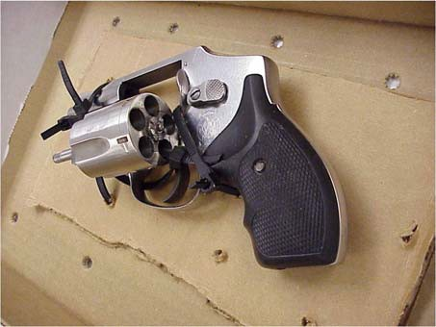

The firearm should be secured with a zip-tie through the action.

The weapon conditions should be noted: cocked/uncocked, safety on/off, sequence of cartridges in the cylinder, etc). For revolvers, the outside of the chamber under the firing pin should be marked as the “1” position before opening and the position/condition of cartridges noted.

##### **Metal Evidence Recovered from Water/Liquid**

Submit immediately in the water in which it was located.

Ensure that the item of evidence is completely submerged, slowing the oxidation process and slowing evidence destruction.

##### **Cartridges and Bullets**

Package spent cartridge cases and bullets so that the tool marks are protected. For example, package each item separately before placing the items in the submission envelope.

##### **Tools**

Such that the area which had to have been used to make the tool mark is protected from further contact with other objects.

For example, the handle of the screwdriver need not be protected but the bladed end must be protected.

##### **Distance determination evidence**

Submitted evidence must be dry – gunshot residue is easily destroyed by bacterial action.

Stabilize the area around the suspected entry point to ensure that any patterns of gunshot residue are maintained in their original condition. This can be accomplished by sandwiching the area of interest between two sheets of packing material.

#### Results

##### **Serial number restorations**

The firearms section issues reports indicating what, if any, portion of the serial number was identifiable after performing restoration techniques. These may be fully restored, partially restored, or inconclusive/unable to be restored.

##### **Comparisons**

Examinations that compare evidence samples to suspected source samples can result in identification of the source or exclusions of a suspected source. In some instances, there are not enough markings on the evidence material to identify or eliminate the suspected source.

##### **Distance determinations**

Results of distance determination examinations are always reported as a range.

## Latent Prints

#### Overview of Services

* Compares unknown friction ridge impressions with known exemplars and renders a conclusion of identification, exclusion, or inconclusive.
* Compares known friction ridge impressions with prints on court records and renders a conclusion of identification, exclusion, or inconclusive.
* The section utilizes an Automated Fingerprint Identification System (AFIS) to search unidentified friction ridge impressions in the database of the Automated Fingerprint Identification Network (AFIN).

The identification process is a quantitative and qualitative examination of the ridge detail present known as the ACE-V method: Analysis, Comparison, Evaluation and Verification.

Instruments and tests utilized will be stated in the results section of the report.

#### Case and Evidence Acceptance

Latent Print evidence submissions should include the following information:

* When a principle is provided in a case, please provide the following: Full Name, Date of Birth (DOB), Louisiana SID Number (State Identification). If a LASID number does not exist for an individual, the submitting agency will need to provide a ten print card.
* Elimination prints from the victim should be obtained, if possible: Example - in residential burglaries – the prints of the homeowners should be provided.

#### Collection and Packaging:

Due to the fragile nature of the evidence, the items should be processed at the scene using powder and tape lifts/hinge lifters. The tape lifts/hinge lifters should be submitted for analysis.

Remember to properly document important information during collection:

Date/time collection

Case number

Exhibit number

Identifier of collector

Location of collection



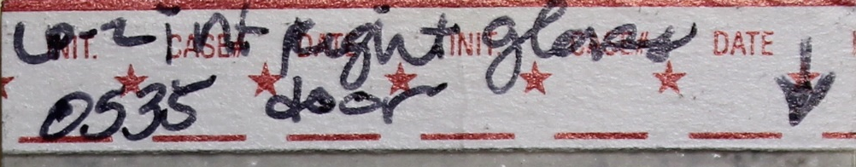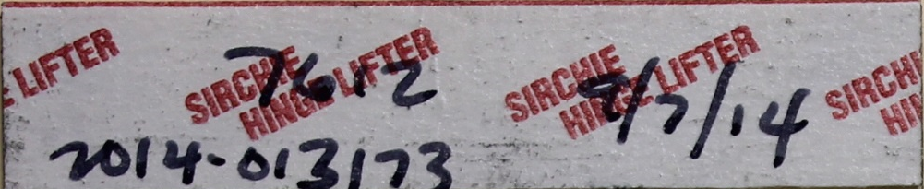

Elimination cards and tape lifts/hinge lifters can be packaged together.

Please lift all the latent prints in what appears to be a simultaneous impression (multiple fingers depositing residue at the same time on a surface) even if some of the latent prints appear to have no ridge detail present. Lifting the adjacent latent prints will help with digit determination (e.g. right middle or left ring finger).

Black or white fingerprint powder will work best in the vast majority of cases when processing non-porous surfaces for latent prints. Normally there is no need to use bi- chromatic or fluorescent powder.

#### Results

Comparisons may result in the following conclusions: exclusion, individualization, or inconclusive.

**Exclusion**

This result means there were sufficient features in disagreement to conclude that two areas of friction ridge impressions did not originate from the same source. Exclusion of a subject can only be reached if all relevant comparable anatomical areas are represented and legible in the known exemplars. Notes and reports shall clearly state if the exclusion refers only to the source or the subject.

**Individualization**

This result means that there are sufficient features in agreement to conclude that two areas of friction ridge impressions originated from the same source. Individualization of an impression to one source is the decision that the likelihood the impression was made by another (different) source is so remote that it is considered as a practical impossibility.

**Inconclusive**

This result can be issued in several situations.

* ***Absence of complete and legible known prints*** – the submitted known prints were of poor quality fingerprints/lacked comparable areas. In such an instance, the inconclusive conclusion means that the impression ***needs may be reexamined*** with the submission of suitable known samples.
* ***Not suitable for comparison***- when corresponding features are observed but not sufficient to individualize or dissimilar features may be observed but not sufficient to exclude. In either case, the inconclusive conclusion means that the unknown impression was neither individualized nor excluded as originating from the same source.

There may be other instances where agencies have adopted procedures to report inconclusive conclusions. These are left to the administrative policies and procedures of the individual agency. However, these policies and reporting procedures must be clearly defined by the agency.

## Digital Forensics

#### Overview of Services

* Collect and present digital information retrieved from evidentiary devices including but not limited to: computers, cell phones, and GPS devices.
* Identify existing concerns and issues regarding computer crimes and act as liaison with other federal, state and local law enforcement agencies.
* Develop and maintain department standards for the investigation of computer and technology crimes and safeguarding of digital evidence.
* Monitor reports of computer and technology related crime.
* Available for consultation in retrieval and safeguarding of technical or digital evidence.
* Provide training and education related to computer and technology crimes and their investigation

#### Case and Evidence Acceptance

All submissions must be accompanied by a court order, search warrant, or consent to search documentation authorizing the search of the evidence before analysis can begin.

The search warrant in its entirety (application and order) is required.

Cell phones and devices may be submitted directly to the Crime Lab for analysis.

All digital evidence and property submitted to the Crime Lab will be thoroughly decontaminated before analysis begins. This decontamination procedure will **eliminate the possibility of Latent Print or DNA collection after processing has been initiated** by the Digital Forensics Unit.

#### Collection and Packaging:

Collection training is provided, upon request, to all submitting agencies/agents.

Due to the sensitive nature and wide array of digital forensic evidence likely to be encountered in the field, the Crime Lab does not include collection information in public access documentation. The Crime Lab is available for specific instructions on collecting and packaging.

#### Results

Reports identify the hardware and software utilized during the examination as well as the items retrieved as a result. Details of items retrieved may be located in a technical report.

Due to the sensitive nature of certain recovered material, the Crime Lab retains the right to submit collected material directly to STPSO evidence in lieu of release to the investigator.

## Video Forensics

#### Overview of Services

* Analog and Digital video from surveillance cameras may be processed to improve the quality of the recording.
* By using smart tools provided by the software/hardware manufacturers, relevant and important video frames can be saved as still images, which can then be further processed to optimize the image.

Equipment used for enhancement includes but is not limited to software and hardware based on technology from companies such as Ocean Systems and Integraph.

#### Case and Evidence Acceptance

When submitting video evidence, indicate in some manner the area of interest on the video. This may be indicated by listing the time in hours, minutes and seconds, or by giving a description of a person, activity, or area of interest.

#### Collection and Packaging:

Many DVR systems record video in a proprietary format. To get the best results possible, when exporting the video from the DVR system for analysis, export in its proprietary format. Every effort should be made to submit the proprietary video player to the lab.

Evidence should be collected in a write protected format such as a CDR or DVDR.

#### Results

Reports identify the hardware and software utilized during processing as well as the number of quality images retrieved as a result. Any images of value retrieved may be issued to the submitting agent in hardcopy or electronic format.

## Crime Scene

#### Overview of Services

* On-site crime scene processing support services, when requested.
* Search for various kinds of forensic evidence including but not limited to biological (e.g. blood and semen), latent print, trace (e.g. hairs, fibers, glass, paint, fire debris, shoe print and tire track impressions), questioned document, tool mark and firearms evidence.
* Vehicles may be brought to the Crime Laboratory Processing Bay with prior approval and/or arrangements made with the Crime Scene Supervisors.
* Analyzes adhesive, porous, non-porous, semi-porous and blood contaminated evidence for the presence of friction ridge impressions.

The Crime Scene Response Vehicle has all necessary supplies and equipment to collect, preserve, and transport physical evidence gathered at crime scenes.

Additional processing may be performed at the Crime Lab facility if all processing could not be performed at the scene.

Processing may be done with the application of powders, dye stains, cyanoacrylate fumes, and blood enhancing reagents. Examinations may be made utilizing lasers and alternate light sources. Scene documentation may be conducted via photography, digital imaging and sketching.

#### Case and Evidence Acceptance

Typically, the Laboratory Crime Scene Team will respond to: Homicides, Attempted Homicides, Abductions, Death Investigations, Officer Involved Shootings, Burglaries, Criminal Sexual Assaults, Assaults, and Property Crimes as well as in house processing for latent prints and/or DNA collection.

STPSO requests - Requests for service are initiated through the Radio Room or by contacting a Crime Lab Supervisor.

Non-STPSO requests - Requests for service are initiated at the discretion of the Crime Lab Director or designee.

#### Collection and Packaging

Crime scene related evidence collected by STPSO personnel should conform to STPSO Departmental policies and procedures and Evidence Room and Crime Lab recommendations for collection and packaging.

The STPSO Crime Lab recommends following STPSO Evidence Collection Guidelines for general evidence collection not covered specifically in the manual.

Due to the fragile nature of Latent Print Evidence, a special notation is made below on proper packaging of latent print evidence being submitted to the STPSO Crime Lab for processing. Evidence should be packaged in paper envelopes, bags, or cardboard boxes in such a way to minimize movement against the container or other items in the container.

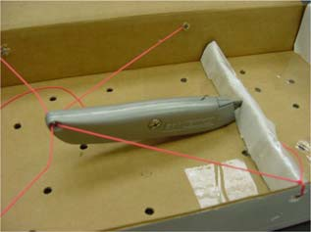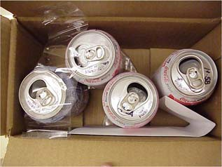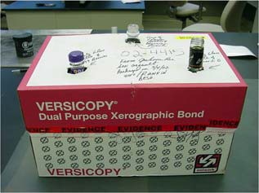

#### Results

All observations and actions performed on scene or on evidence are described in the supplemental report.

STPSO reports – Reports are available through RMS.

Non-STPSO reports – Reports are available through the STPSO Records Department or will be issued to the agency upon evidence pick-up.

**Version History**

LSG.2017 Original Issue